**CASE STUDY**

**ON**

**BANKING SYSTEM FOR LOAN MANAGEMENT**

By:-

Bhavya Garg

23SCSE1010435 (Adm. No.)

B.Tech. CSE (Core)

**Title**: **BANKING SYSTEM DATABASE FOR LOAN MANAGEMENT**

**Subtitle**: Optimizing Loan Processing and Interest Rate Management in Financial Institutions

**Introduction**

* The banking sector heavily relies on advanced database systems to manage loans and interest rates effectively. As adopted technologies to handle relevant data and applications, etc.
* Aims to implementation for loan management by focusing on its design, functionality and impact on efficiency.
* Understanding how banking system database can optimize loan management which is crucial to enhance service delivery and maintains competitive advantages in market.

**Problem**

* The challenge is the inefficiency of traditional loan processing methods.
* Leads to increases errors and time of processing to handle data.

For example, manual data entry can result in a 20% error rate in loan applications, causing significant operational setbacks. Additionally, banks may experience a 30% increase in processing time due to outdated systems.

**Methodology**

* Data was collected as researched on web as through bank professional’s response data, analysed loan management processed data and current database technologies used in financial institutions data available.
* The study focused on major Indian banks over a period of one year, examining both customer-facing and back-office operations.

**Findings and Analysis**

* High volume of processing leads to errors and lack of integration between different systems.
* Increased demand on solutions and growing reliance on data analytics.
* Change from traditional practices and initial costs associated with new system’s implementation.

**Solution**

* Ensuring reliable processing of loan applications and repayments.
* Enabling detailed reporting and real-time data analysis.
* ER Modelling

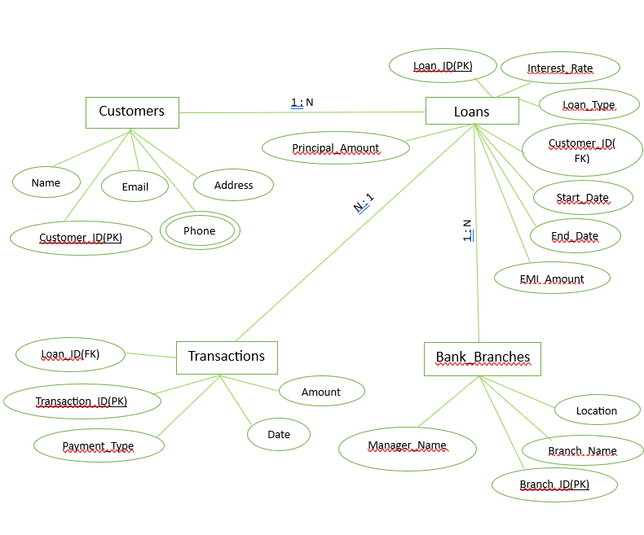

**Results and Impact**

* 40% reduction in processing time and 25% reduction in errors.
* Improved operational efficiency significantly.

**Lessons Learned & Recommendations**

* Automation can drastically improve efficiency and comprehensive training for staffs is essential to adapt to new technologies.
* Regular updates and maintenance of database system to use advancement technologies.

**Link** – https://github.com/Team-Projects123/Case-Study-Banking-System.git

**Conclusion**

* This case study demonstrates that implementing database effectively address to existing inefficiencies while enhancing overall customer experience.
* As technology continues to advance, bank also update them with time.
* Financial Institutions are encouraged to adopt updated advance systems.